Network Optimization of Large-Scale CNNs for Applications in Autonomous Machines

A Srivathsava Reddy-
Department of Computer Science and Engineering, Koneru Lakshmaiah Education Foundation, Bowrampet, Hyderabad-500043, Telangana, India.
2420030634@gmail.com

Abstract —Personal expense management is an important aspect of financial planning. However, manually recording expenses, organizing transactions, monitoring monthly budgets, and identifying spending patterns can be time-consuming and error-prone. This paper presents an AI-Enhanced Expense Tracking System designed to simplify expense management through automated expense organization, interactive financial summaries, budget monitoring, and intelligent spending insights. The proposed system follows a microservices architecture in which user authentication, expense management, and expense analysis are organized into separate services. Spring Boot is used for backend development, while REST APIs enable communication between application components. JWT-based authentication can provide secure access to user accounts, and service discovery and request routing can be managed using Eureka and Spring Cloud Gateway. The artificial intelligence component is designed to suggest expense categories from transaction descriptions and generate meaningful insights from spending patterns through an external Large Language Model API, when integrated. The system aims to improve the usability, maintainability, and scalability of personal expense management while helping users make more informed financial decisions.

Index Terms—Expense Tracking, Generative Artificial Intelligence, Microservices Architecture, Spring Boot, REST API, Financial Analytics, Budget Monitoring, Expense Categorization.

- Introduction
Managing personal finances requires individuals to record daily transactions, monitor spending habits, and maintain budgets according to their financial goals. Traditional expense-tracking methods, such as spreadsheets and manual records, require continuous user effort and may lead to incomplete entries, incorrect categorization, and difficulties in identifying spending trends.

R Sai Charan -
Department of Computer Science and Engineering, Koneru Lakshmaiah Education Foundation, Bowrampet, Hyderabad-500043, Telangana, India.
2420030140@gmail.com

Several digital applications provide facilities for recording expenses and displaying financial summaries. However, users may still need to categorize transactions manually or interpret charts and reports themselves. Intelligent assistance can make this process easier by suggesting appropriate expense categories and explaining spending patterns in simple language.

The AI-Enhanced Expense Tracking System is proposed to address these challenges by combining expense management, financial analytics, and artificial intelligence with a modular microservices architecture. Users can record, update, delete, and view expenses containing details such as amount, description, date, and category. The application can calculate total expenditure, summarize monthly spending, display category-wise expenses, and support budget monitoring.

The proposed AI component can analyze transaction descriptions and spending summaries to provide category suggestions and personalized insights. For example, a transaction described as “lunch at a restaurant” may be categorized as food, while a monthly report may highlight a category that contributes substantially to total expenditure. Such outputs are intended to support user understanding rather than replace professional financial advice.

The use of microservices separates the application into manageable components and allows individual services to be maintained and extended independently. The main objective is to develop a practical expense management solution that combines structured financial records with intelligent analysis and a user-friendly interface.

A. Expense Tracking Applications
Expense tracking applications help users record daily transactions, organize expenditures, and monitor their financial activities. These applications provide facilities to maintain expense records, view transaction histories, and calculate total spending over a selected period. Digital expense tracking reduces the effort required to maintain manual records and improves the accessibility of financial information. However, users may still need to categorize transactions manually and analyze their spending habits.

B. Personal Budget Management
Personal budget management systems help users establish spending limits and compare actual expenditure against planned budgets. Monthly summaries and category-wise reports allow users to identify major expenses and understand how their money is being spent. Budget monitoring can also help users recognize when their expenditure approaches a predefined limit. Integrating these features into an expense tracking application provides a convenient way to manage financial records and monitor spending patterns.
C. Artificial Intelligence in Expense Categorization

Artificial intelligence can support expense management by interpreting transaction descriptions and suggesting appropriate categories. For example, a transaction containing the description “electricity bill” may be assigned to utilities, while a “bus ticket” may be classified under transportation. A Large Language Model API can be used to process textual descriptions and generate category suggestions. However, the accuracy of these suggestions depends on the transaction description and the model's response, so users should be allowed to verify or correct the suggested category.

D. Financial Data Analysis
Financial data analysis involves processing transaction records to identify spending patterns, calculate monthly expenditure, and determine the categories that contribute most to total spending. Charts, summary tables, and budget utilization indicators help users understand their financial activities. AI-generated explanations can further describe patterns identified from calculated financial summaries. Combining numerical analysis with understandable explanations may help users make more informed decisions about their spending hab

- Literature Survey
A. Traditional Expense Tracking Applications
Traditional expense-tracking applications allow users to record transactions, classify expenses, and review spending summaries. These applications provide a convenient alternative to paper-based records and spreadsheets. However, the amount of automation and the availability of personalized insights vary between platforms. The proposed system aims to combine transaction management with automated categorization and understandable spending analysis.

B. Budgeting and Personal Finance Applications
Budgeting applications help users establish spending limits, monitor expenses, and understand their financial habits. Applications such as YNAB emphasize budget-based financial planning, while other personal finance tools offer transaction summaries and spending reports. These features demonstrate the importance of organizing financial information and presenting it in an understandable form. The proposed system focuses on combining these basic functions with an AI-assisted analysis component.
C. Automated Expense Management Systems
Automated expense management systems reduce manual work by processing transaction information and organizing financial records. Such systems demonstrate the value of structured data, automated workflows, and centralized reporting. Nevertheless, the degree of automation depends on the features available in each application. The proposed system explores description-based category suggestions and natural-language spending insights as additional capabilities.
D. Artificial Intelligence in Financial Applications
Artificial intelligence and natural language processing can be applied to financial data to identify patterns, classify textual information, and generate explanations. A Large Language Model can interpret an expense description and suggest a category based on its meaning. When provided with suitable aggregated spending information, it can also generate a readable summary of expenditure patterns. However, generated outputs may be incorrect and should be validated against the underlying financial records.
E. Microservices-Based Application Development
Microservices architecture divides an application into independently managed services that communicate through defined interfaces. Spring Boot supports the development of Java-based backend services, while REST APIs enable communication between components. Service discovery and gateway routing can support communication and request management in a distributed application. Applying this architecture to expense tracking can improve modularity and simplify future feature development.

. Research Gap
The reviewed approaches highlight the importance of expense recording, budgeting, financial reporting, and automated data processing. A potential improvement is to combine these functions with AI-assisted expense categorization, personalized spending explanations, and a modular microservices architecture in one application. The proposed system addresses this opportunity by integrating expense management and financial summaries with an AI analysis service, subject to the successful implementation and validation of the AI integration.
the prediction, as shown in Fig. 2. In this paper, two techniques have been implemented:
- L1-Unstructured Pruning
- Random-Unstructured Pruning

- Methodology
This section details the model’s architecture, the data sources used, and the optimization techniques utilized. The dataset has a 3D point cloud data with the images and cali-bration files for data points which are taken using a data loader. The target class contains three categories: Car, Pedestrian, and Cyclist. The preprocessing step includes random rotation (20-degree range), scaling (5% range), and horizontal flipping. The batch size of the data loader is set according to the VRAM in the GPU. The data is divided into training, testing, and validation sets.
YOLOv4 is one of the most popular object detection archi-tectures based on the Darknet Framework [9]. The network architecture uses the mish activation function while applying batch normalization to the YOLO architecture layers. Upsam-pling and Downsampling have been used to improve the speed and stability of the model. The Adam optimizer has been chosen since it best combines the properties of AdaGrad and RMSProp algorithms that can handle sparse gradients on noisy problems. The training is performed for 150 epochs.
- Optimization Techniques
Large CNN networks often have suboptimal runtime per-formance due to high memory and processing power re-quirements, drastically increasing the inference speed. Pruning and quantization are often applied to improve energy savings and inference speed without significantly increasing accuracy losses in the model. The improvement in efficiency signif-icantly affects the affordability of edge devices capable of autonomous driving and other complex tasks.
  - Pruning: Pruning involves the elimination of certain weights to decrease inference requirements and reduce the model size. There are two main pruning technique types:
    - Structured pruning: involves eliminating weights by ac-tively modifying the network, i.e., the total number of parameters is reduced , as shown in Fig. 1. In this paper, two techniques have been implemented:
      - Ln-Structured Pruning
      - Random-Structured Pruning
    - Unstructured pruning: involves eliminating weights by zeroing any weights that do not significantly affect

Fig. 1. Structured Pruning

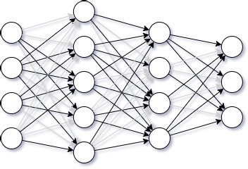

Fig. 2. Unstructured Pruning

Both types of pruning techniques have been studied in this paper. Pruning was performed to eliminate 2, 4, 7, 10, 15, 20, 30, and 40 percent of nodes/weights. Section IV contains more details about the results and analysis.
  - Quantization: Quantization involves lowering bit-widths from floating-point precision (to INT8 and FLOAT16) by approximation, drastically reducing the memory requirements. There are two main quantization technique types:
    - Post-Training Quantization (PTQ): involves conversion of bit-widths after the complete model has undergone training. There are two techniques that are commonly used:
      - Post-Training Quantization - Static (PTQ-S): in-volves fusion of activation functions into preceding layers of the model wherever possible. Calibration

dataset is required for determination of optimal quantization parameters. PTQ-S is most effective when compute efficiency needs to be increased and memory bandwidth is low.
      - Post-Training Quantization - Dynamic (PTQ-D): involves conversion of bit-widths after the com-plete model has undergone training, i.e., weights are quantized ahead of time. PTQ-D is most effec-tive when loading weights from memory dominates the model execution time.
    - Quantization-Aware Training (QAT): involves conver-sion of bit-widths during the training process, i.e., be-tween epochs. The models influence quantization for achieving higher accuracy. During training, the weights are calculated with floating-point precision while simul-taneously applying rounding and clamping to simulate the lower bit-width. After conversion, the activation functions and weights are quantized while the activation functions are fused onto the preceding layers. There are three modes of QAT:
      - Static
      - Dynamic
      - Weight-only
PTQ-D techinique has been studied in this paper. PTQ-D was applized on the Linear layers of the network. Section IV contains more details about the results and analysis.
- Dataset
The KITTI dataset [] was used in the implementation. The KITTI dataset consists of more than 12919 images. Four datasets were used for training the model which include:
- Velodyne Point-Cloud Data: 3D point-cloud data that serves as training and testing data for the model. Totally 29GB in size.
- Left-Side Color Image Data: 2D images (of only left-side perspective) for prediction visualization. Totally 12GB in size.
- Camera Calibration Matrices: for prediction visualization. Totally 16MB in size.
- Training labels: input labels from training. Totally 5MB in size.
The dataset consists of three categories: Cars, Pedestrians, and Cyclists. In this paper, the prediction precision, recall, and f1-score are averaged across the classes.
- Testing Environment
Testing was performed on a system with the following specifications:
- CPU: i7 8th Gen (non-overclocked)
- GPU: NVIDIA GTX 1070 Ti (8GB GDDR5 VRAM)
(non-overclocked)
- RAM: 16GB
- OS: Ubuntu 18.04 LTS (64-bit)
The tests are performed on a random sample consisting of 1414 iterations and then averaged out.
- Results & Analysis
This section shows the results of the tests performed and also analyzes the results obtained. The tests were performed on a system with specifications as mentioned in Section III-C. The tests include results from training a base model, which was pruned at 2, 4, 7, 10, 15, 20, 30, and 40 percent of nodes/weights. The tests are performed on a random sample of 1414 iterations and then averaged out. The confidence thresh-old has been set to 85%, i.e., after pruning, only predictions with more than 85% confidence will be considered.
The base model and the pruned models were again tested with PTQ-D enabled only for the Linear layers of the network.
- Comparison of Average Inference Times
The average inference time is the amount of time a model takes to make a prediction (i.e., produce an output) from the time it receives the input. Network Optimization aims to minimize the inference time, i.e., the lower the inference time, the better the optimization. This section gives all inference times in milliseconds (ms).
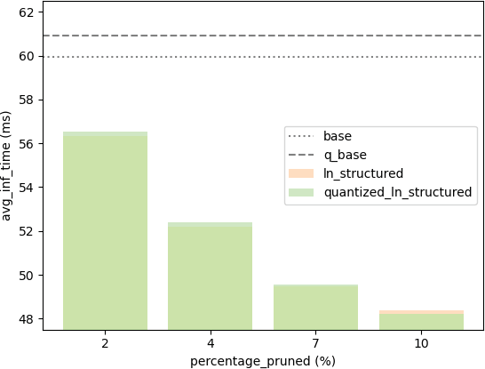

Fig. 3. Average inference times using Ln-Structured Pruning Technique

Fig. 3 shows the average inference times for the given percentage of pruned nodes using the L1-Unstructured Prun-ing technique. It includes the average inference times with quantization enabled and disabled, however, the difference is not significant. Here, only four pruning results are shown as the rest of the pruned models have low confidence. From this graph, we can observe that the average inference times are significantly lesser and gradually fall with increasing pruning percentage. At 10% pruning, the average inference time dropped by approximately 20%.
Fig. 4 shows the average inference times for the given percentage of pruned nodes using the Random-Structured Pruning technique. Here, due to low confidence five of the eight pruning results have been omitted, i.e., greater than 7%. From this graph, we can observe that the inference times are
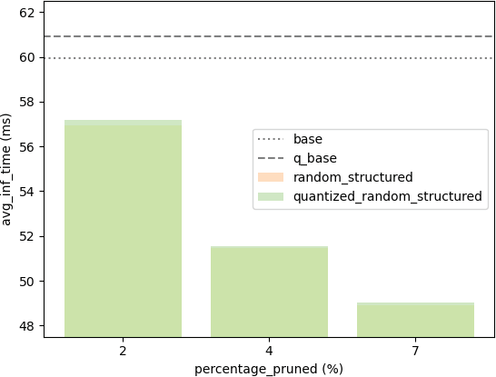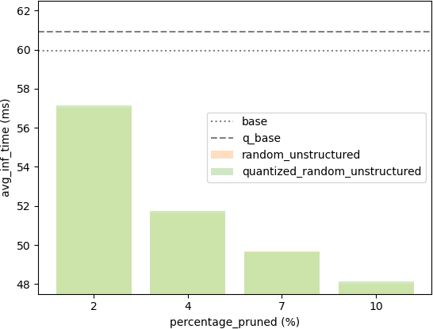

Fig. 4. Average inference times using Random-Structured Pruning Technique

gradually falling. At 7% pruning, the average inference time dropped by approximately 20% again.
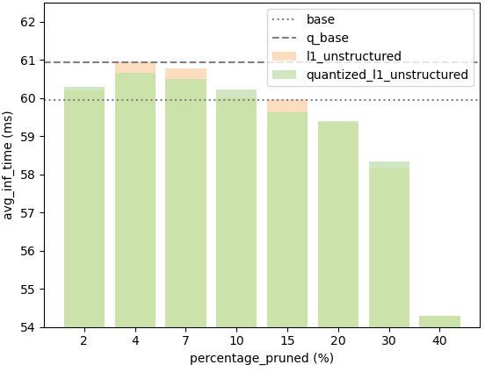

Fig. 5. Average inference times using L1-Unstructured Pruning Technique

Fig. 5 shows the average inference times for the given percentage of pruned nodes using the L1-Unstructured Pruning technique. This is the first pruning technique with all eight pruning levels. From this graph, we can observe that the inference times are significantly lesser for the 2, 10, 15, 20, 30, and 40 percent pruning levels with respect to the base model’s inference time. At 40% pruning, the model steeply declines in the inference times. However, this may also be a sign of high loss.
Fig. 6 shows the average inference times for the given percentage of pruned nodes using the Random-Unstructured Pruning technique. It includes the average inference times with quantization enabled and disabled. Due to low confidence, four of the eight pruning results have been omitted, i.e., greater
Fig. 6. Average inference times using Random-Unstructured Pruning Tech-nique

than 10%. From this graph, we can observe that the inference times are significantly lesser for the 2, 10, 15, 20, 30, and 40 percent pruning levels with respect to the base model’s inference time. At 40% pruning, the model steeply declines in the inference times. However, this may also be a sign of high loss. At 40% pruning, the average inference time dropped by approximately 12%, which is the lowest compared to other techniques at much lower levels of pruning.
With each of the techniques, it is observable that the average inference time is considerably reduced with an increase in the percentage of nodes/weights pruned. Quantization further reduces the average inference time by a small amount in some cases.

- Comparison by F1-Scores
The F1-score is defined as the harmonic mean of the precision and recall of a model. It is a metric that is often used to measure the performance of a model.
From Fig. 7, it can be observed that the F1-scores decrease as the percentage of nodes/weights pruned is increased. This also causes a fall in confidence in the prediction of the model, which inadvertently increases the loss in a model. L1 Unstructured has the most gradual decrease in f1-scores among the four techniques. In contrast, the F1-scores of the other three techniques – namely Ln Structured, Random Structured, and Random Unstructured – have a steep decline indicating a dramatic rise in loss.
Among the four techniques, L1-Unstructured performs the best with an F1-score of 0.785, at the highest pruning percent-age of 30% while providing a speed-up of 3.1%. However, among structured pruning techniques, Ln-Structured pruning performs the best with an F1-score of 0.745, at the highest pruning percentage of 2% while providing a speed-up of 6.1%.

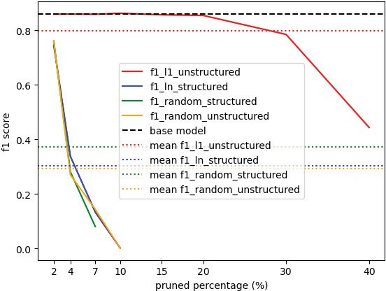

Fig. 7. F1-scores of base model and pruned models at various pruning levels

- Conclusion
This paper describes two types of network optimizations – pruning and quantization – in detail. Pruning and quanti-zation were then applied to improve the inference time of the model while simultaneously measuring its performance by extensively testing the model. The comparison of four pruning techniques in this paper yields a trade-off criteria for optimizing CNNs, i.e., inference speed vs performance for 3D object detection using point cloud data.
The tests revealed that the L1-Unstructured pruning tech-nique performs the best with an F1-score of 0.785, at the highest pruning percentage of 30% while providing a speed-up of 3.1%. However, among structured pruning techniques, Ln-Structured pruning performs the best with an F1-score of 0.745, at the highest pruning percentage of 2% while providing a speed-up of 6.1%. These results indicate that a significant improvement in inference time can be obtained without drastically sacrificing the model’s performance.
This work can be further extended in the following four ways:
  - Implementing other pruning techniques (both structured and unstructured) that can be applied to the model and tested to check for better inference times without loss in performance.
  - Implementing both unstructured and structured pruning techniques on the same model at varying pruning per-centages.
  - Implementing other quantization techniques, such as Quantization-Aware Training (QAT).
  - Implementing other network optimization techniques, such as Factorization and Convolution Optimization, to optimize the model further while minimizing loss in performance.
ed.). CRC Press. https://doi.org/10.1201/9780849375477
- F. Bounini, D. Gingras, V. Lapointe and H. Pollart, ”Autonomous Vehicle and Real Time Road Lanes Detection and Tracking,” 2015 IEEE Vehicle Power and Propulsion Conference (VPPC), Montreal, QC, Canada, 2015,
pp. 1-6, doi: 10.1109/VPPC.2015.7352903.
- Martin Simon, Stefan Milz, Karl Amende, and Horst-Michael Gross, “Complex-YOLO: An Euler-Region-Proposal for Real-time 3D Object Detection on Point Clouds”, arXiv:1803.06199v2 [cs.CV] 24 Sep 2018.
- Andreas Geiger, Philip Lenz, and Raquel Urtasun, “Are we ready for Autonomous Driving? The KITTI Vision Benchmark Suite”, Conference on Computer Vision and Pattern Recognition (CVPR), 2012.
- Fernando Julio Cendra, Lan Ma, Jiajun Shen, and Xiaojuan Qi, “SL3D: Self-supervised-Self-labeled 3D Recognition”, arXiv:2210.16810 [cs.CV] 30 Oct 2022.
- Yiyang Shen, Rongwei Yu, Peng Wu, Haoran Xie, Lina Gong, Jing Qin, and Mingqiang Wei, “ImLiDAR: Cross-Sensor Dynamic Message Propa-gation Network for 3D Object Detection”, arXiv:2211.09518 [cs.CV] 17 Nov 2022.
- Alberto Tamajo, Bastian Plaß, and Thomas Klauer, “Shrinking unit: a Graph Convolution-Based Unit for CNN-like 3D Point Cloud Feature Extractors”, arXiv:2209.12770 [cs.CV] 26 Sep 2022.
- Yuan Yao, Yuanhan Zhang, Zhenfei Yin, Jiebo Luo, Wanli Ouyang, and Xiaoshui Huang, “3D Point Cloud Pre-training with Knowledge Distillation from 2D Images”, arXiv:2212.08974 [cs.CV] 17 Dec 2022.
- Redmon, Joseph and Farhadi, and Ali, “YOLOv3: An Incremental Im-provement”, arXiv, 2018

References
  - Informa Healthcare, , & Karwowski, W. (Eds.). (2006). International Encyclopedia of Ergonomics and Human Factors - 3 Volume Set (2nd

